Data Science and Analytics

Boone, NC 2026

Team ID

Table of Contents
Table of Contents …………………………………………………………………………………………………………… 1
Introduction and Data Overview ………………………………………………………………………………………. 2
Data Dictionary ….………………………………………………………………………………………………………… 3
Purpose ………………………………………………………………………………………………………………………. 5
Methods ………………………………………………………………………………………………………………………… 6
Results …………………………………….……………………………………………………………………………………. 7
Conclusions ………………………………………………....……………………………………………………………… 9
Next Steps …………………………………………………………………………………………………………….……… 11
Digital Scientific Poster ……………………………………………………………………………………………….… 12
Bibliography and References …………………………………………………………………………………………. 13
Appendix ……………………………………………………………………………………………………………………… 14
Appendix A – Latitude and Longitude …………………….………………………………………………………. 14
Appendix B – SRAI Formula ………………………………….………………………………………………………. 14
Appendix C – List of Locations ….………………………….………………………………………………………. 16
Appendix D – Excel Workbooks …………………………….………………………………………………………. 20
Appendix D.1 – 2010 Raw Data …….…………………….……………………………………………………. 20
Appendix D.2 – 2025 Raw Data ….…………………….……………………………………………………. 23
Citations ……………………………………………………………………………………………………………………… 26
Student Copyright Checklist ………………………………………….………………………………………………. 27

Introduction and Data Overview
Ski resorts are often a top choice for many tourists to do physical exercise in a beautiful snow-covered environment while still having fun with friends and family. However, with the growing presence of global warming in the world, it is becoming harder to find resorts to go to in the winter. As the planet warms up, the temperature of the planet affects nature cycles and leads to snow and ice melting, raising the sea level. A raised sea level can flood coasts, erode land, and damage coastal ecosystems. Additionally, damaged environments can lead to ski resorts becoming dangerous, reducing their attractiveness to the tourists.
In fact, a 2018 report from NOAA’s climate branch predicted that by the end of the century, temperatures would rise “an average of 6°F to 9°F” and would increase “the rain-to-snow transition anywhere from 1,500 feet to 3,000 feet” (Scott). This means that for many ski resorts located at lower altitudes, there will not be sufficient snow. Typical family ventures to these resorts might be canceled if they do not have enough snow for safe skiing. This will reduce tourism income for these resorts and cause them to go out of business. To this end, as the world warms, it is necessary to understand how global warming affects ski resorts to develop an effective strategy to support them.
This project aims to examine this important topic through analyzing climate data in 2010 and 2025. We utilized data for eighteen different climate metrics across over 550 resorts initially to create a Ski Resort Attractiveness Index (SRAI) that provides a broad description of the condition of ski resorts before taking a deeper look into how global warming affects temperature and snowfall at these ski resorts. There are some interesting discoveries in our results that contradict our predictions and we attempted to provide an explanation for in our conclusions. Finally, we offered suggestions for future analysis to further examine the impact of global warming on other aspects of ski resorts so they can be minimized.

Data Dictionary

Field Name | Data Type | Description | Example
location | string | Stores the city and country of the ski resort | Beaver Creek, USA
latitude | float | Along with longitude, creates the coordinate system to determine the location of the ski resort | 48.5544426
longitude | float | Along with latitude, creates the coordinate system to determine the location of the ski resort | -109.7921487
time | string | The date when the data was collected | 2025-01-01
temperature_2m_mean (°C) | float | Average air temperature at 2m above ground | 5.0
wet_bulb_temperature_2m_mean (°C) | float | Average temperature at 2m above ground when factoring humidity | 2.7
snowfall_sum (cm) | float | The depth of snowfall | 1.89
precipitation_sum (mm) | float | Total precipitation | 3.10
rain_sum (mm) | float | Volume of rainfall | 0.40
snowfall_water_equivalent (mm) | float | Amount of water in snowfall | 2.70
apparent_temperature_mean (°C) | float | Average “feels-like” temperature | -0.4
relative_humidity_2m_mean (%) | int | Average humidity at 2m above ground | 83
wind_gusts_10m_max (m/s) | float | Maximum sustained wind gusts at 10m | 18.20
wind_speed_10m_max (m/s) | float | Maximum wind speed at 10m | 8.40
wind_speed_10m_mean (m/s) | float | Average wind speed at 10m | 5.57
cloud_cover_mean (%) | float | Average percent of sky covered by clouds | 63
cloud_cover_max (%) | float | Maximum cloud cover observed | 100
cloud_cover_min (%) | float | Minimum cloud cover observed | 0
shortwave_radiation_sum (MJ/m²) | float | Total incoming solar radiation | 2.57
daylight_duration (s) | float | Time between sunrise and sunset | 28106.08
surface_pressure_mean (hPa) | float | Average atmospheric pressure on surface | 1005.8
vapour_pressure_deficit_max (kPa) | float | Maximum difference between saturation and actual vapour pressure | 0.19

Purpose
Global warming is a threat to the economy because it has severe impacts to many industries in society. A study published in 2024 noted that each “1°C warming reduces world gross domestic product (GDP) by over 20%” (Bilal, et al.). One industry affected by global warming is ski resort tourism. As the planet warms up, it can become difficult for the ski resorts to maintain their operations. One 2023 study found that the risk of insufficient snow for ski resort tourism increases with global warming, with “3% and 98% of the 2,234 ski resorts studied in 28 European countries [expected to be at] very high risk for snow supply under global warming of 2°C and 4°C, respectively” (François, et al.). Even with such small increases in temperature, the snow many resorts get will not be sufficient for valid operation. Consequently, the ski season becomes shorter “due to late opening or early closure of ski slopes” which removes a major source of income averaging about “$252 million a year” and exceeding “$5 billion over the past two decades” (Igini).
In a press release from the International Ski and Snowboard Federation (FIS) after their 2024 partnership with the UN’s World Meteorological Organization (WMO), they committed to working to “highlight the far-reaching impacts of rising global temperatures on snow and ice cover and to establish practical initiatives to strengthen scientific and sporting dialogue” (“FIS”). In the past year, the partnership has produced numerous dialogues on the effects of climate change, including one on how glacier retreat can negatively affect the winter ski season.

However, there is hardly one single solution that can solve every problem global warming creates. Although the partnership between FIS and WMO is an important step in dealing with global warming to help the ski resort industry, people and corporations should still take steps to slow the progression of global warming - aim to reduce carbon emissions, be more energy efficient, and take other actions. In this way, we can maintain a similar standard of living while collectively helping to reduce the impacts of global warming and ensuring a prosperous economy.

Methods
We transformed our data through multiple steps to identify any useful information.
- First, we compiled a general list of popular ski resorts and their locations from various websites. We ended up with 554 resort locations spread across over thirty countries.
- The locations were run through a Python script (see Appendix A) to determine the geographical latitude and longitude of each resort.
- We used Open-Meteo’s Historical Weather API to extract climate data from 2010 and 2025. In these two years, the following variables were measured everyday:
  - Mean temperature
  - Mean apparent temperature
  - Mean wet bulb temperature
  - Mean, maximum, and minimum cloud cover
  - Mean relative humidity
  - Precipitation sum (including rain sum, snowfall sum, and snowfall water equivalent sum)
  - Daylight duration
  - Mean surface pressure
  - Maximum vapour pressure deficit
  - Maximum wind gusts
  - Mean and maximum wind speed
  - Shortwave radiation sum

- We used an objective formula to determine the “Ski Resort Attractiveness Index” (SRAI) of each resort (see Appendix B). The formula includes all the above variables with different weightings to account for more impactful measures, like temperature and precipitation.
- We took the average of the daily mean temperatures of ten randomly selected resorts in each of the four subareas (the Alps, US West, US Northeast, and Japan) to compare the averages from 2010 to 2025.
- We performed the same analysis using the same ten randomly selected resorts in each subarea to compare the total average snowfall from November to March in 2010 and 2025.
- Finally, we performed T-tests on the average daily mean temperatures and total average snowfall from 2010 to 2025 to determine any statistical significance in our results.

Results
We began our analysis by creating the “Ski Resort Attractiveness Index” (SRAI) for each resort. When comparing the change in SRAI from 2010 to 2025, we discovered that around 80% of resorts experienced an approximately 25% decrease in SRAI, with many in the Alps and US West regions, while 20% of resorts experienced an approximately 13% increase in SRAI, most notably in the US Northeast and Japan regions (Figure 1).
We then took a detailed look into a random sample of ten resorts in these four major ski resort subareas: the Alps, US West, US Northeast, and Japan. For this analysis, we analyzed the average temperatures of the entire year and the total average snowfall during the northern ski season (defined as the days from November to March). We limited the timeframe to only the winter months when analyzing snowfall because these subareas are all in the Northern Hemisphere.
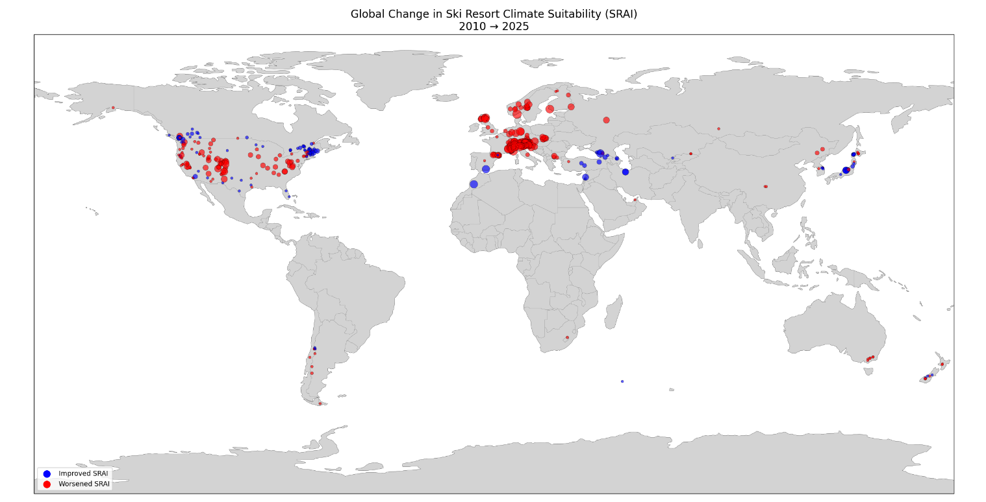
Temperature: The graphs are split into four separate panels to easily compare each subarea and two different-colored lines are drawn to distinguish data for 2010 and 2025. The Alps had the most notable increase in temperature (2.7°C, P < 0.001) between these years as indicated by the 2025 line appearing above the 2010 line numerous times (Figure 2A).
Figure 1. SRAI (ski resort attractiveness index) was determined by a formula weighting different variables like temperature, pressure, and cloud cover. This was applied to all 554 ski resorts for the years 2010 and 2025. Red circles signify a decrease in SRAI from 2010 to 2025, and blue circles signify an increase in SRAI from 2010 to 2025. Size of circle represents magnitude of change in SRAI (bigger circle = bigger change, smaller circle = smaller change).

The other three subareas had less noticeable differences of temperatures between 2010 and 2025. The US West (Figure 2B) seemed to have experienced a slight increase in temperatures (1.4°C, P = 0.04), while US Northeast (-0.7°C, P = 0.40) and Japan (0.9°C, P = 0.23) had insignificant differences in temperatures (Figures 2C-2D).
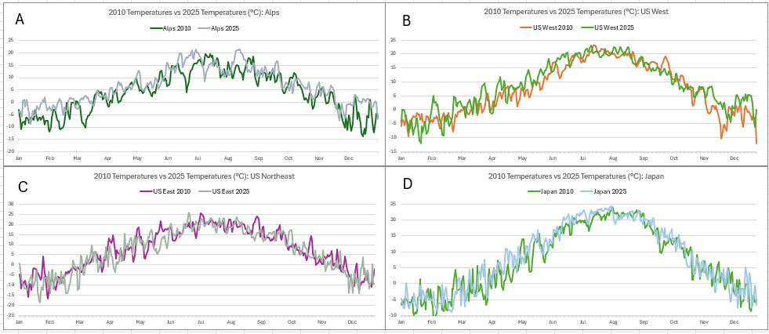
Figure 2. Temperature comparisons split between four graphs: the Alps (A), US West (B), US Northeast (C), and Japan (D). Daily temperature data averaged over ten resorts to reduce variation, then graphed for the years 2010 and 2025.
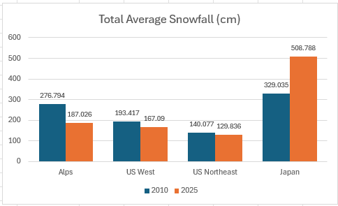
Snowfall cover: The results from comparing the total average snowfall in both 2010 and 2025 are largely consistent with our predictions. We found that for the Alps and both US West and US Northeast, snowfall did decrease overall. There was a 32% decrease for the Alps (P = 0.01), whereas 13% and 7% decreases were noted for US West (P = 0.44) and US Northeast (P = 0.72), respectively. Surprisingly, Japan’s snowfall in 2025 increased by 180cm, a 54% increase (P = 0.001) compared to 2010 (Figure 3).
Figure 3. Total average snowfall from Nov 1 to Mar 31 in four regions. Snowfall of 10 resorts were averaged to reduce variation. The total shown is the sum of these averages throughout the season.

Conclusions
Our results are largely what we expected. For the most part, global warming does negatively impact the factors that help ski resorts attract tourists by rising temperature and decreasing snowfall during the peak ski season. However, there are a few interesting – even surprising – results that are revealed by our analysis.
First, some ski resorts had an increase in SRAI over the 15-year period. Their locations include the Caucasus area, northeast US, western Canada, and Japan. We believe these increases are due to the other climate variables used in our formula when determining the SRAI. Although snowfall and temperature are two of the biggest factors, we have included other factors such as cloud cover, humidity, wind speed, and radiation. With many of these ski resorts located near large bodies of water, it is possible that wind and humidity become equally important to the overall SRAI calculations.
Second, out of the four subareas analyzed, only the Alps has clear changes in temperatures as the line representing 2025 temperatures is noticeably above the line representing 2010 temperatures at least 21 times and dips below the 2010 line only four times (early July, late August, early October, and late November). Conversely, the temperature graphs of US West, US Northeast, and Japan are similar in both years. We believe this might happen because US West, US Northeast, and Japan border major oceans (the Pacific and Atlantic), which may lead to a less severe warming effect. Indeed, the average temperature in the Alps substantially increased by 71% while the other regions only changed by about 10%, supporting the possibility that the land temperatures are cooled by the ocean. This may also explain why many resorts in the Alps have a lower SRAI because warmer temperatures will limit the amount of snow available in these ski resorts for skiers.
Most surprisingly, out of the four subareas, only Japan’s snowfall increases, by 54%. This is unexpected because we assumed that global warming will melt more snow before it reaches the ground, therefore lowering the total snowfall, as seen in the Alps and the United States. The surprising result noted for Japan’s snowfall led us to do more research into how this could happen. We learned that beginning in 2020, strong La Niña conditions have given Japan record levels of snowfall. For example, in 2024, Hokkaido and Nagano recorded “an impressive 311cm of snow in December” and reached “a 10-year high for early season snowfall”; at the end of the ski season of 2024, Japan had a snowfall total of “12 [to] 13 metres” (“From”). This suggests that although global warming is generally known to decrease the total snowfall in ski resorts, it can have opposite impacts if the right conditions are present to favor the formation of a La Niña, leading to more snowfall in the ski resorts and consequently increasing the SRAI.

Next Steps
In the future, we will work to expand the scope of our dataset and perform additional data analysis. Due to our concerns about the amount of computational power required to analyze a large dataset, we only chose to analyze two years of data. We could have analyzed all fifteen years of climate data if we have better computer technology to support the analysis. By analyzing all fifteen years of climate data, we can highlight more smooth transitions from year-to-year and identify any potential outliers where there began any unusual events (like Japan’s record snowfall caused by La Niña). We could also have included more ski resorts to represent more locations around the world and create a more thorough picture of how global warming is affecting different types of ski resorts.
We will also do more exploratory analysis with the dataset. Our current analysis consists of a very broad analysis as well as a focused look only at how the average temperature and total snowfall affect ski resorts and their SRAI. In the future, we want to similarly analyze the effect of other climate factors on ski resorts and their SRAI, such as if wind and humidity eventually become equally impactful in the SRAI calculations.
One question remains to be answered in this work is how these changes caused by global warming and in SRAI affect the revenue of the ski resorts over the years. We would like to perform this analysis because it will be interesting to see if the ski resorts in Japan – with more snowfall and higher SRAI –actually have more business and higher revenue. Our expectation is that this will be the case. If this is proven, we can develop strategies to help ski resorts that have lower revenue to improve their business, such as by recreating an environment using artificial snow to increase snow availability and SRAI. Countries can also consider building new ski resorts in regions where the SRAI is expected to be higher to keep the skiing industry strong.
We hope that this analysis can help bring even greater attention to the issue of global warming. Ski resorts will continue to feel the burden until we can minimize the impact of global warming. However, the effects of global warming may have a further reach than expected and are likely to affect other winter sports, which adds to the urgency of addressing the problem. This problem is complex; there is no one single solution that can fix the whole problem completely. Small steps such as transitioning to green energy, improving efficiency, reducing waste, and maintaining sustainability are underway. However, it will require everyone in the world to rally together to implement government policies and practices that proactively reduce global warming.

Digital Scientific Poster

Bibliography & References
Bilal, Adrien, and Diego R. Känzig. “The Macroeconomic Impact of Climate Change: Global vs. Local Temperature.” NBER, 13 May 2024, www.nber.org/papers/w32450.
“FIS and WMO Partnership Highlights The Harmful Effects of Climate Change on Winter Sports and Tourism.” World Meteorological Organization, 3 Oct. 2024, wmo.int/news/media-centre/fis-and-wmo-partnership-highlights-harmful-effects-of-climate-change-winter-sports-and-tourism.
François, Hugues, et al. “Climate Change Exacerbates Snow-Water-Energy Challenges for European Ski Tourism.” Nature News, Nature Publishing Group, 28 Aug. 2023, www.nature.com/articles/s41558-023-01759-5.
“From Hokkaido to Honshu: Japan’s 2024/25 Season in Review.” MountainWatch Travel, 30 Apr. 2025, mountainwatch.travel/blog/japans-2024-25-season-in-review/.
Igini, Martina. “Global Warming Costs US Ski Industry $252M a Year.” Earth.Org, Earth.Org, 1 Nov. 2024, earth.org/us-ski-industry-at-risk-of-collapsing-as-global-warming-accelerates.
Scott, Michon. “Climate & Skiing.” NOAA Climate.Gov, 19 Nov. 2018, www.climate.gov/news-features/climate-and/climate-skiing.

Appendix

Appendix A – Latitude and Longitude:
This code was used to get the latitude and longitude of each resort (‘resorts’ is a multiline string of ski resort locations).
Appendix B – SRAI Formula:
This formula was used to combine our data into an objective measure of the ski resort.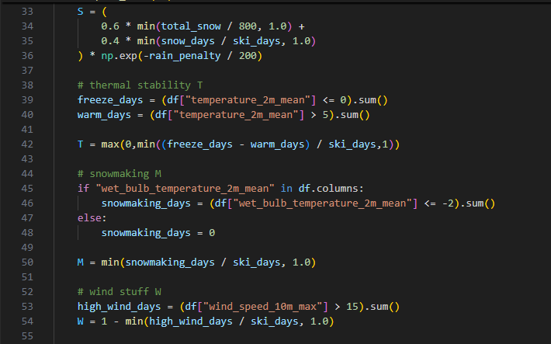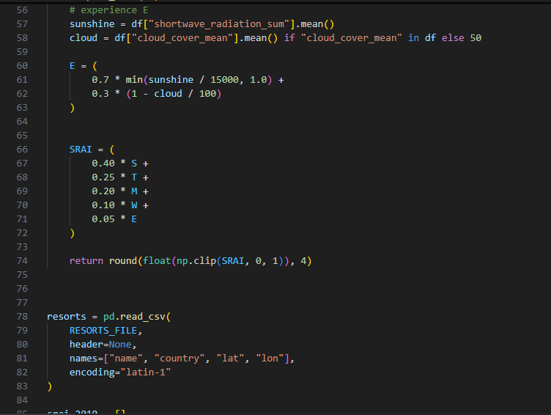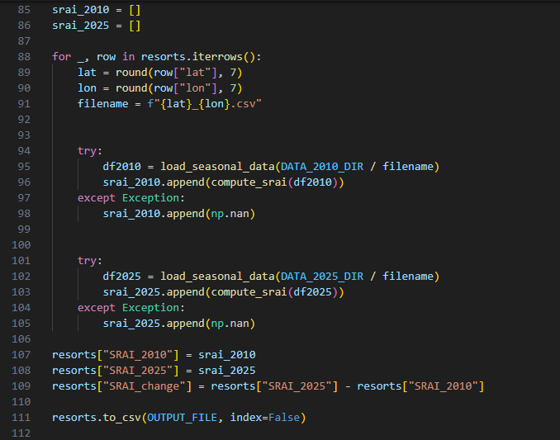

Appendix C – List of Resort Locations:
This contains screenshots of all 554 resorts used in our analysis, along with their latitudes and longitudes. The screenshots begin on the next page.



Appendix D – Excel Workbooks:

Appendix D.1 – 2010 Raw Data:
Due to the full workbook being over 200,000 rows long, the first 100 rows will be shown.
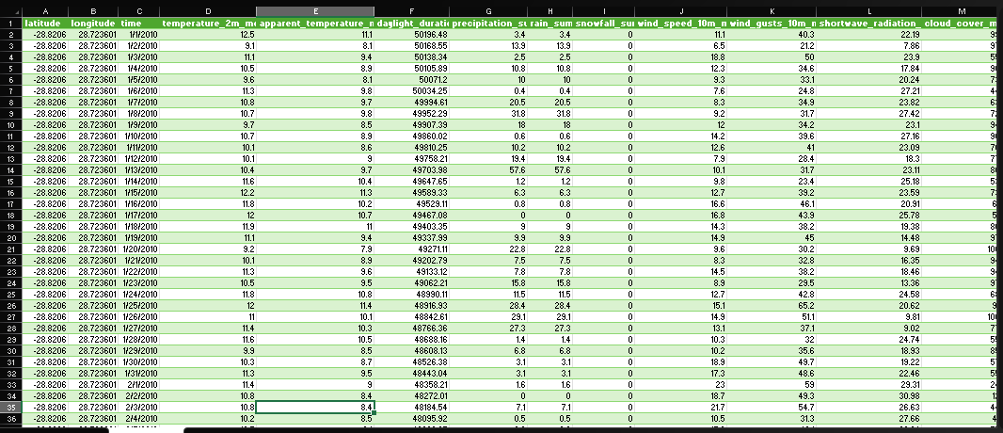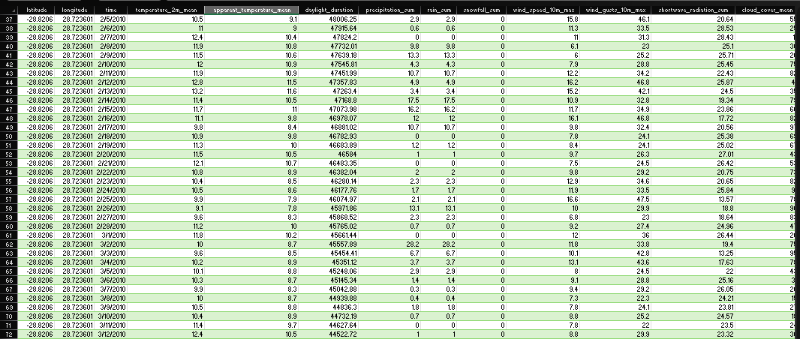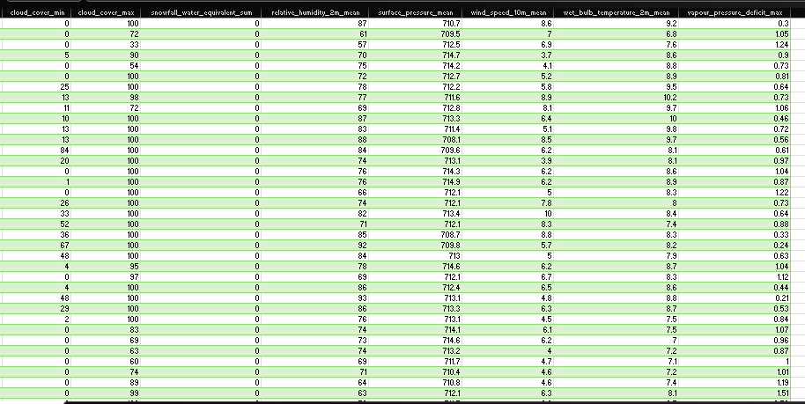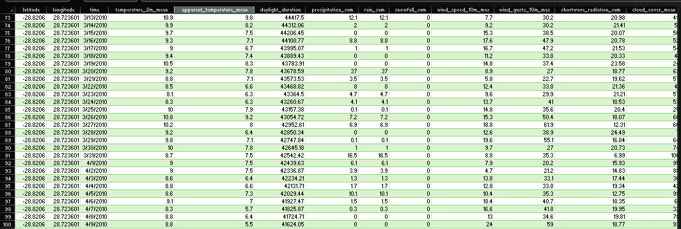

Appendix D.2 – 2025 Raw Data:
Due to the full workbook being over 200,000 rows long, the first 100 rows will be shown.
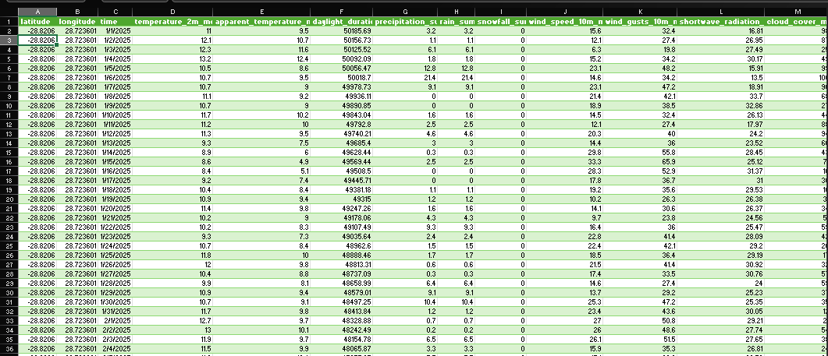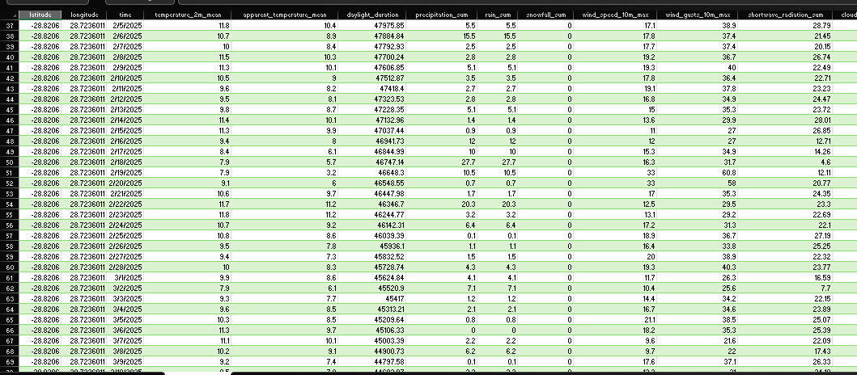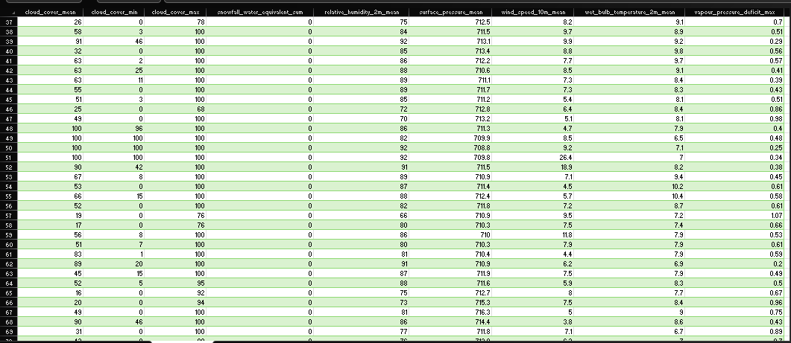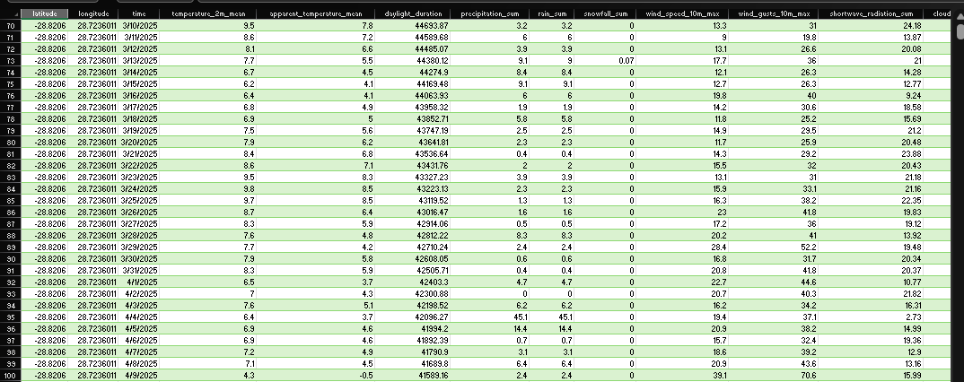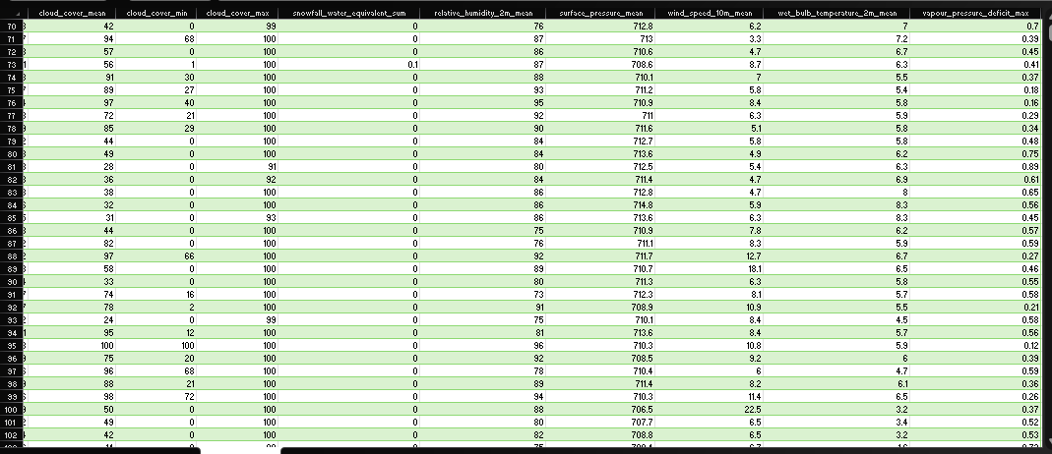

Citations
The font used in this documentation portfolio is Aptos. As seen below, we have no licensing issues with using the font for documentation (as it is considered a print output).

Historical Weather data from Open-Meteo.com was used for our analysis. As seen below, we have licensing rights to transform and build upon the data collected.

Student Copyright Checklist

